**Experiment no. 4**

**Aim : To calculate steady state error using Matlab**

**Software required : Matlab 7.0**

**Theory:**

Steady-state error is defined as the difference between the input (command) and the output of a system in the limit as time goes to infinity (i.e. when the response has reached steady state). The steady-state error will depend on the type of input (step, ramp, etc.) as well as the system type (0, I, or II).

**Evaluating Steady-State Errors :**

In figure1, a step input and two possible outputs are shown. Output 1 has zero steady-state error, and output 2 has a finite steady-state error.

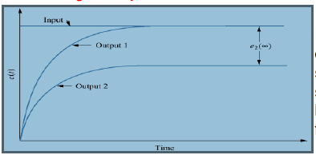

Figure 1:Response of step input

In figure 2,Output 1 has a zero steady-state error.Output 2 has a finite steady-state error.Output 3 has a infinite steady state error.

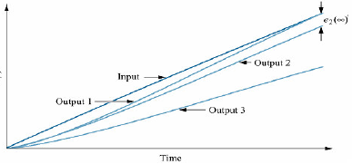

Figure 2

Let us now look at the error from the perspective of the most general block diagram.

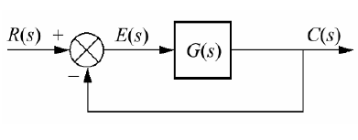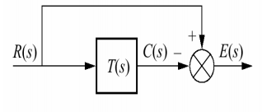

Figure 3:closed loop transfer function

Since the error is the difference between the input and the output of a system, we assume a closed loop system, the error E(s) is the difference between the output C(s) and the input R(s) for a unity feedback system.

**Steady-State Error in Terms of T(s) :** Consider the figure 3. To find E(s), we write E(s)=R(s) - C(s) but C(s) = R(s)T(s).

Substituting C(s) into R(s) and solving for E(s) yields E(s) = R(s)[1-T(s)]

Appliying the final value theorem, we obtain



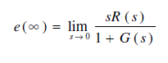

**Table 1:steady state error for different inputs for type 0,1,2**

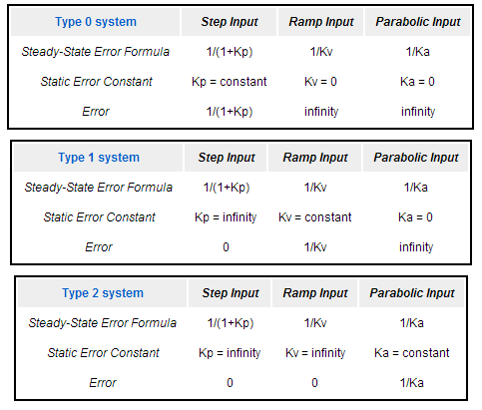

**Where**







**Matlab commands**

1. **lsim: lsim simulates the (time) response of continuous or discrete linear systems to arbitrary inputs.**

**[y,t,x] = lsim(sys,u,t,x0)**

1. **tf:** **creates a continuous-time transfer function with numerator(s) and denominator(s) specified by num and den.**

**sys = tf(num,den)**

**Result:-**

**Conclusion:-**